Curriculum Vitae

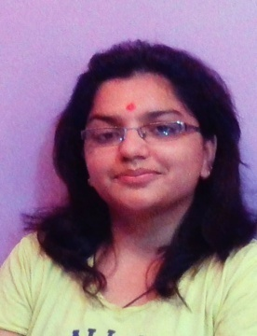

MANSI PARASHAR
E-mail Id.: mansiparashar@ymail.com
Contact No.: +91-8439323022; 7536864524

Career Objective
To make positive contribution as part of a dynamic and well- reputed Organization in a position where my Management, Decision- Making and Communication Skills will be appreciated and enhanced.

EDUCATIONAL BACKGROUND
Degree | School/College | Board/University | Year of Completion | Percentage
BBA | ShriKrishna Institute of Management & Science | MJP Rohilkhand University, Bareilly | 2013 | 70.39
Class XII | Shivdale | CBSE | 2009 | 50.00
Class X | Shivdale | CBSE | 2007 | 45.6

Market Survey  Place:  Chandausi (U.P)  In  2012 | Project Title: Consumer Buying Behavior regarding Branded and Non- Branded Ready- Made Garments.  Project Description: This was a Research Oriented Project to conduct a survey among the Prospective Customers and to compare the data.  Responsibilities:  - Studying the product  - Developing the questionnaire  - Conducting the Survey  - Assimilating and interpreting the data  - Presenting the final findings to the management.  Duration: 2 Weeks

Strength | - Self- Motivated and Flexible  - Confident  - Good Communication Skills  - Dedicated and Hard- Working  - Passionate about Work  - Leadership Qualities  - Coordinative and Cooperative  - Never Give Up Attitude

Personal Details
Date of Birth | 30th September, 1991
Hobbies | - Listening Music.  - Playing Games.  - Traveling
Address | Postal : 324 Parashar Niwas, Shivpura Kankhal, Haridwar, Uttrakhand (U.K.)  Correspondence: H3 021 Assotech Spring Field Society, Zeta 1 (Near Amrapali Grand), Greater Noida

